RATCHET PIPE THREADER (BSPT)
Compact tool for threading small pipes, suitable for use in difficult corners and close to walls.
The Die Heads have large clearance holes to prevent chips out. Standard Tapper Pipe
Threading; Complete Threading in one cut. Compact Light weight Packed in Metal and
Plastic carrying box.

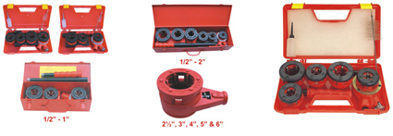

PRODUCT SPECIFICATION
Prod. No. | 111C | 111E | 111G | 111H | 111J
Size (Inch) | ½ - 1 | ½ - 1.¼ | ½ - 2 | 3/8 - 2 | 1.¼ - 2
Size (mm) | 15-25 | 15-32 | 15-50 | 10-50 | 32-50
Wt. (Kgs.) | 6.000 | 6.000 | 15.500 | 16.000 | 11.600
Prod. No. | 111M | 111N | 111P | 111R | 111S
Size (Inch) | 4 | 2.½ - 3 | 5 | 6 | ¼ - 6
Size (mm) | 100 | 65-80 | 125 | 150 | 6-150
Wt. (Kgs.) | 14.800 | 21.000 | 30.500 | 28.500 | 131.200

ROTARY PIPE CUTTER
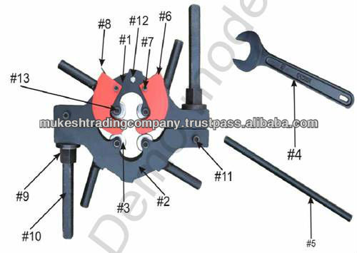

Hand Operated Rotary Pipe Cutter with best technology to cuts the Cast Iron, Ductile Iron and Mild Steel pipes with four wheel cutters with only 45° to 60° clearance and its spring action guide helps to alignment on pipe for correct cutting. Wheels cutters are made of high shock resistant tool steel. It is used at trenches, running pipe lines where under water, in pits and in noise free zones etc and it is normally available up to 24° and 30° and 36° on request.

Prod. No. | Size (Inch) | Wt. Kgs.
306A | 3-6 | 22.5
306B | 6-9 | 28.3
306C | 9-12 | 32.3
306D | 12-15 | 35.3
306E | 15-18 | 85.0
306F | 21-24 | 82.0
306G | 30 | 186.0
306H | 36 | 210.0

TUBE ROLLER BENDER

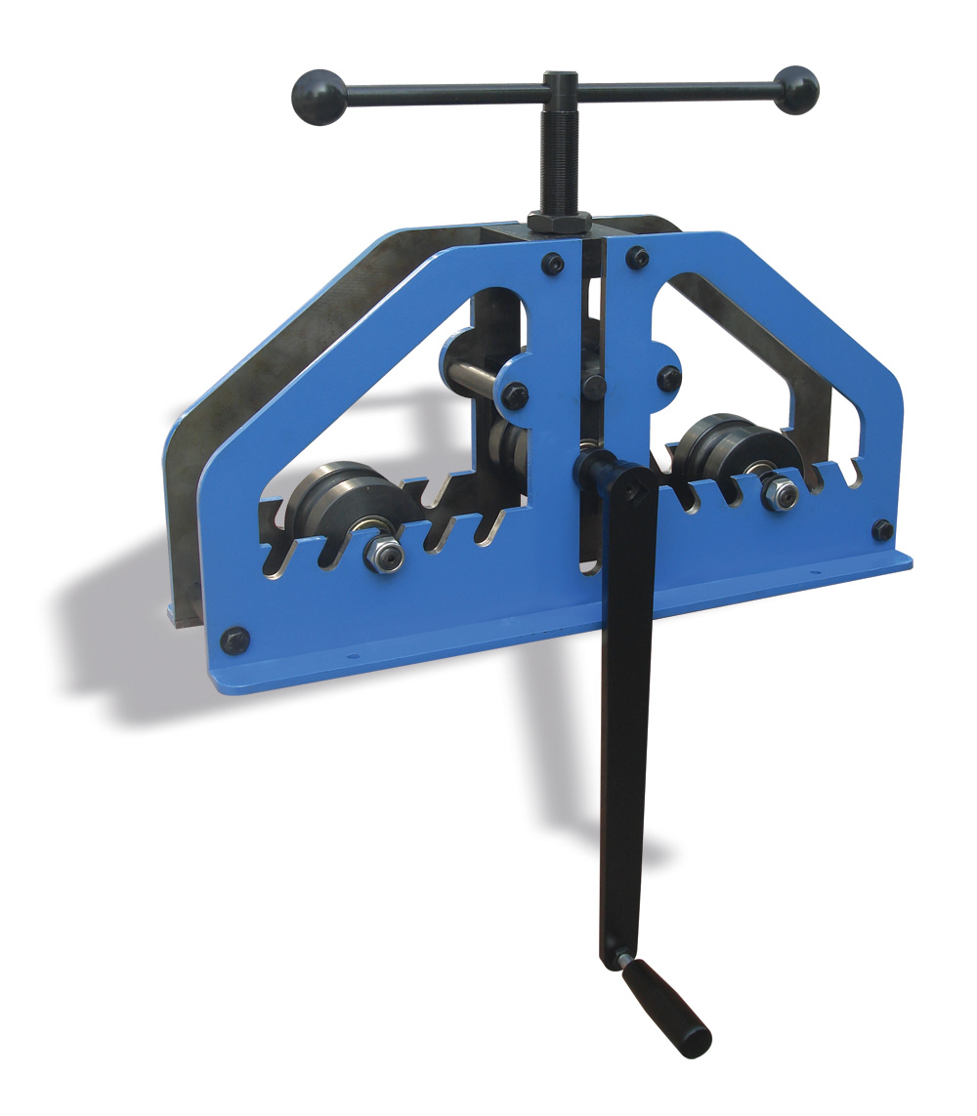

Prod No. | 161A | 161B
Size Max (inch) Round Pipe | 1 | 1.1/2
Size Max (inch) Round Tube | 1.1/4 | 2
Size Max (inch) Round Tube | 1.1/4 | 2
Size Max (inch) Rect. Tube | ½ x 1.1/4 | 1 x 2
Size Max (inch) Flat | ¾ | 1.1/4
Wt. (Kgs.) | 25.000 | 33.000

PORTABLE CONDUIT PIPE BENDER WITH VICE

Fabricated Potable conduit pipe bender with vice is designed for conduit pipe bending with lever system upto 180° and SG iron strong Self locking pipe vice 35mm for holding pipe while plumbing job required for threading and cutting etc.

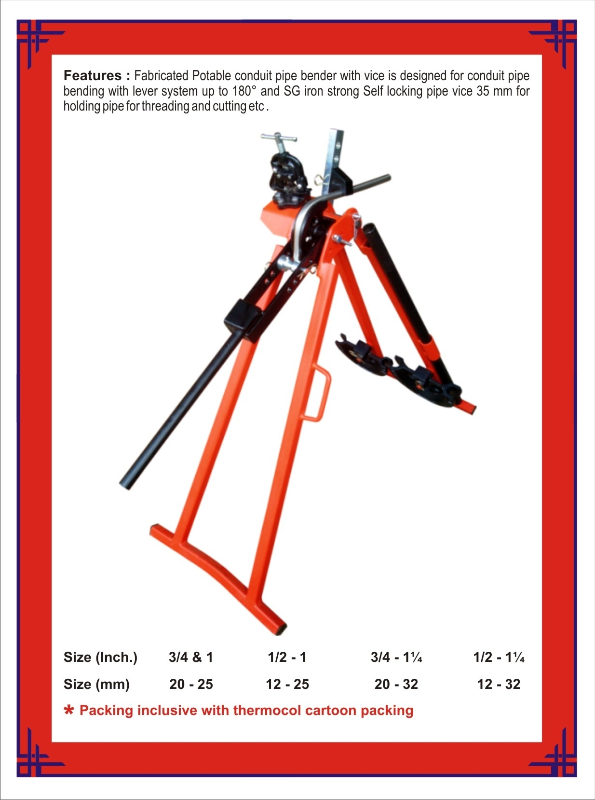

PRODUCT SPECIFICATIONS:
Prod. No. | Size (Inch.) | Size (mm) | No. of Formers | N.Wt. (Kgs
233A | 3/4 & 1 | 20 - 25 | 2 | 30.500
233B | ½ - 1 | 12 - 25 | 3 | 32.000
233C | 3/4 - 1.¼* | 20 - 32 | 3 | 35.000
233D | ½ - 1.¼ | 12 - 32 | 4 | 36.500

PORTABLE ELECTRIC PIPE THREADER (BSP)
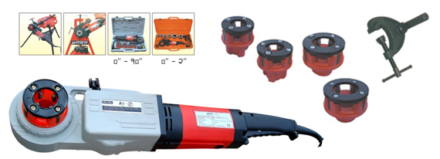
Suitable for threading of pipe thread BSPT & NPT thread on request. It is used under difficult situation e.g. Corners, Celling, Trench etc. Simple and safe operation. Easy change of die head. No adjustment. A handy clamping device. A compact and light weight body packed in PVC blow box & size available upto 2".
Prod. No. | Size/Capacity Inches | Voltage | Power | Speed rpm | Dies Including Inches | Portable PVC Box CM | G.Wt  (Kgs.)
155A | 1/2-1 | 230/V/50 Hz | 1050 W | 32 | ½, ¾, 1 | 60x20x9 | 12.8
155B | 1/2-1/4* | 230/V/50 Hz | 1050W | 32 | ½, ¾, 1, 1¼ | 60x20x9 | 14.0
155C | 3/8-1¼ | 230/V/50 Hz | 1050W | 32 | 3/8, ½, ¾, 1, 1¼ | 60x20x9 | 14.8
155D | ¼-1¼ | 230/V/50 Hz | 1050W | 32 | ¼, 3/8, ½, ¾, 1, 1¼ | 60x20x9 | 15.5
155E | ½-2 | 230/V/50 Hz | 1050W | 32 | ½, ¾, 1, 1¼, 1½, 2 | 90x45x15 | 22.5

